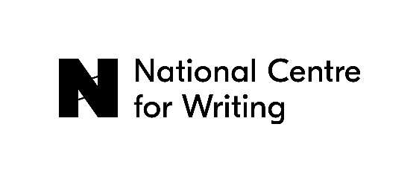

Visible Communities residencies 2024

In 2024, the National Centre for Writing would like to appoint three translators in virtual residence for the Visible Communities programme. We are also offering two short residencies in Norwich as part of the programme.

The National Centre for Writing’s Visible Communities programme aims to:

- Diversify access routes to literary translation in the UK
- Strengthen links between the literary translation community and UK diaspora communities
- Contribute to the debate around decolonising literary translation
- Expand the range of literature published in translation in the UK

Visible Communities virtual residencies 2024

The aim of the virtual residency is to support literary translators to work on a project that addresses in some way the concerns of the Visible Communities programme. We will commission our virtual residents to write a piece for the NCW website about their project and to curate a translation-related Meet the World event during the residency.

The three residencies will run simultaneously for three months, from September to November 2024. We will pay a fee of £3,000 per residency.

The fee is based on approximately one day per week over that period, though the timing of the work is flexible and will depend on the individual project proposed. During the residency, the emphasis will be on time for research and writing, with the final deadline for commission at the end of December 2024.

We will programme regular online meetings with the three translators in virtual residence, offering an opportunity for you to share your work in progress and gain feedback from each other. You will also be offered a mentoring session with an experienced literary translator who will give feedback on your work and advice on your literary translation career.

The Visible Communities residencies are open to UK-based Black, Asian and Ethnically Diverse literary translators working from any language into English. We are particularly interested in collaborating with literary translators and writers who translate from or have some knowledge of the diaspora and heritage language communities within the UK.

If you are interested in this opportunity, please send a cover letter which should include the following information:

- why you are interested in this opportunity and what you will bring to the Visible Communities programme
- the areas of interest or issues you propose to explore during the residency and the approach that you will take
- your ideas for a translation-related Meet the World event
- your relevant experience

Please also include a CV and a translation sample (up to 2000 words) and send your application to residencies@nationalcentreforwriting.org.uk with the subject title Visible Communities virtual residency.

The deadline for applications is Monday 20th May 2024.

Visible Communities cottage residencies 2024-25

We are offering two short residencies in the Dragon Hall cottage in Norwich. Each residency will offer:

- Two weeks of time to translate
- The opportunity to meet other writers and translators in Norwich
- A zoom meeting with one of our mentors who will give feedback on your work as well as professional development advice
- The opportunity to produce commissioned content for NCW’s digital platforms

Each residency will run for two weeks; the dates are:

- Monday 2nd December to Friday 13th December 2024
- Monday 20th January to Friday 31st January 2025

The translators in residence will be hosted in the cottage at Dragon Hall. The Cottage is a small two-bedroom house with sitting room, library, kitchen and bathroom. Please note that the stairs up to the bedrooms are rather steep, in typical Norwich style. The National Centre for Writing will cover the cost of travel within the UK to Norwich for the selected translators and a stipend of £300 per week.

If you are interested, please send us:

- a description of the manuscript or project on which you will work during the residency
- a covering letter explaining why you wish to take part in the residency, what you will bring to it, what you hope to get out of it and what support you would like from the mentor at this stage in your career
- your availability for the residency (December and/or January)

Please also include a CV and a translation sample (up to 2000 words) and send your application to residencies@nationalcentreforwriting.org.uk with the subject title Visible Communities cottage residency.

The deadline for applications is Monday 20th May 2024.

